Task 2 – SQL query practice
SELECT * FROM Sales;
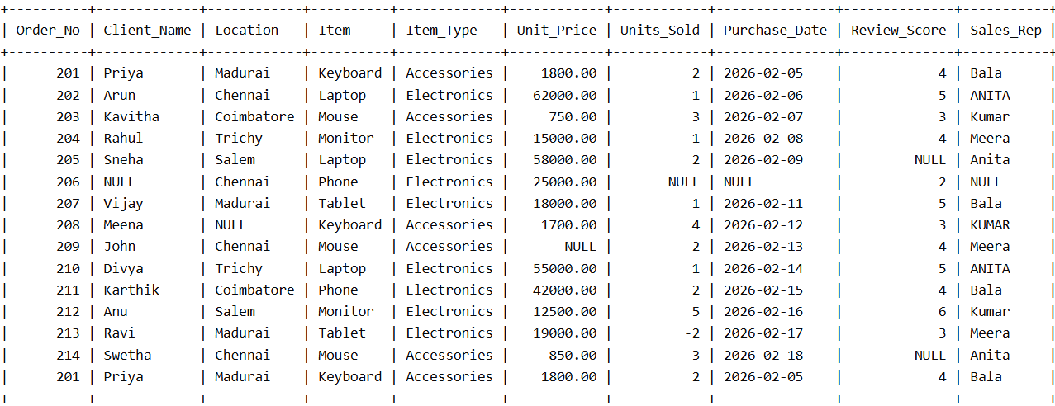
SELECT * FROM Sales WHERE Location = 'Chennai';
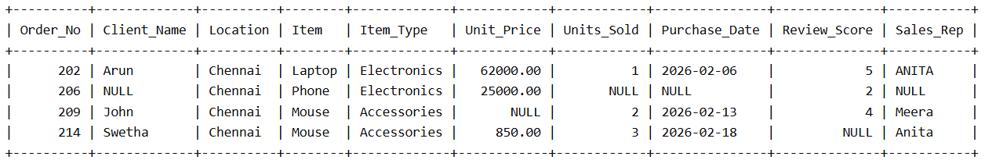
SELECT Order_No, Client_Name, Item, Unit_Price
FROM Sales
WHERE Item = 'Laptop' AND Unit_Price > 50000;
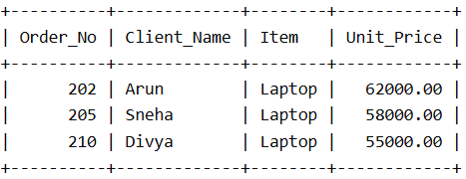
SELECT Order_No, Client_Name, Item, Unit_Price
FROM Sales
ORDER BY Unit_Price DESC;

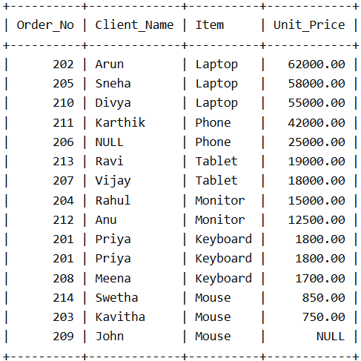
SELECT COUNT(*) AS Total_Orders
FROM Sales;
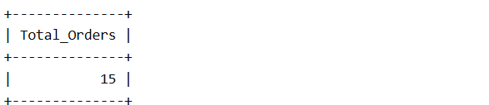
SELECT
SUM(Units_Sold) AS Total_Quantity,
AVG(Unit_Price) AS Average_Price
FROM Sales;
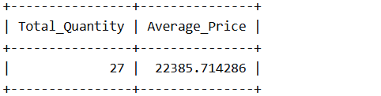
SELECT
Location,
COUNT(*) AS Total_Orders
FROM Sales
GROUP BY Location;
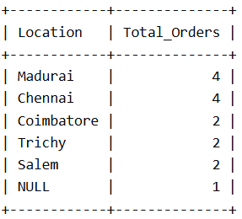
SELECT
Item,
SUM(Units_Sold) AS Total_Quantity
FROM Sales
GROUP BY Item;
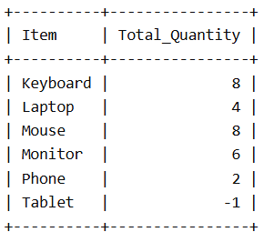
SELECT
Location,
COUNT(*) AS Total_Orders
FROM Sales
GROUP BY Location
HAVING COUNT(*) > 2;
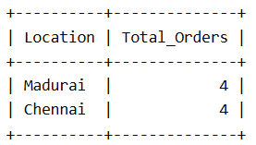
SELECT
MIN(Unit_Price) AS Minimum_Price,
MAX(Unit_Price) AS Maximum_Price
FROM Sales;
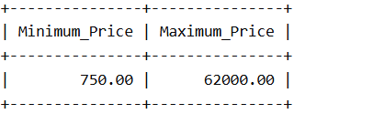
SELECT
Order_No,
Client_Name,
Item,
Unit_Price
FROM Sales
WHERE Unit_Price BETWEEN 10000 AND 60000
ORDER BY Unit_Price DESC;
